**Power BI**

* Power BI: -
* Data Visualization tool and Business Intelligence tool
* Collection of apps, data connectors and software services which are used to get data from different data sources , transforms data and produces useful reports.

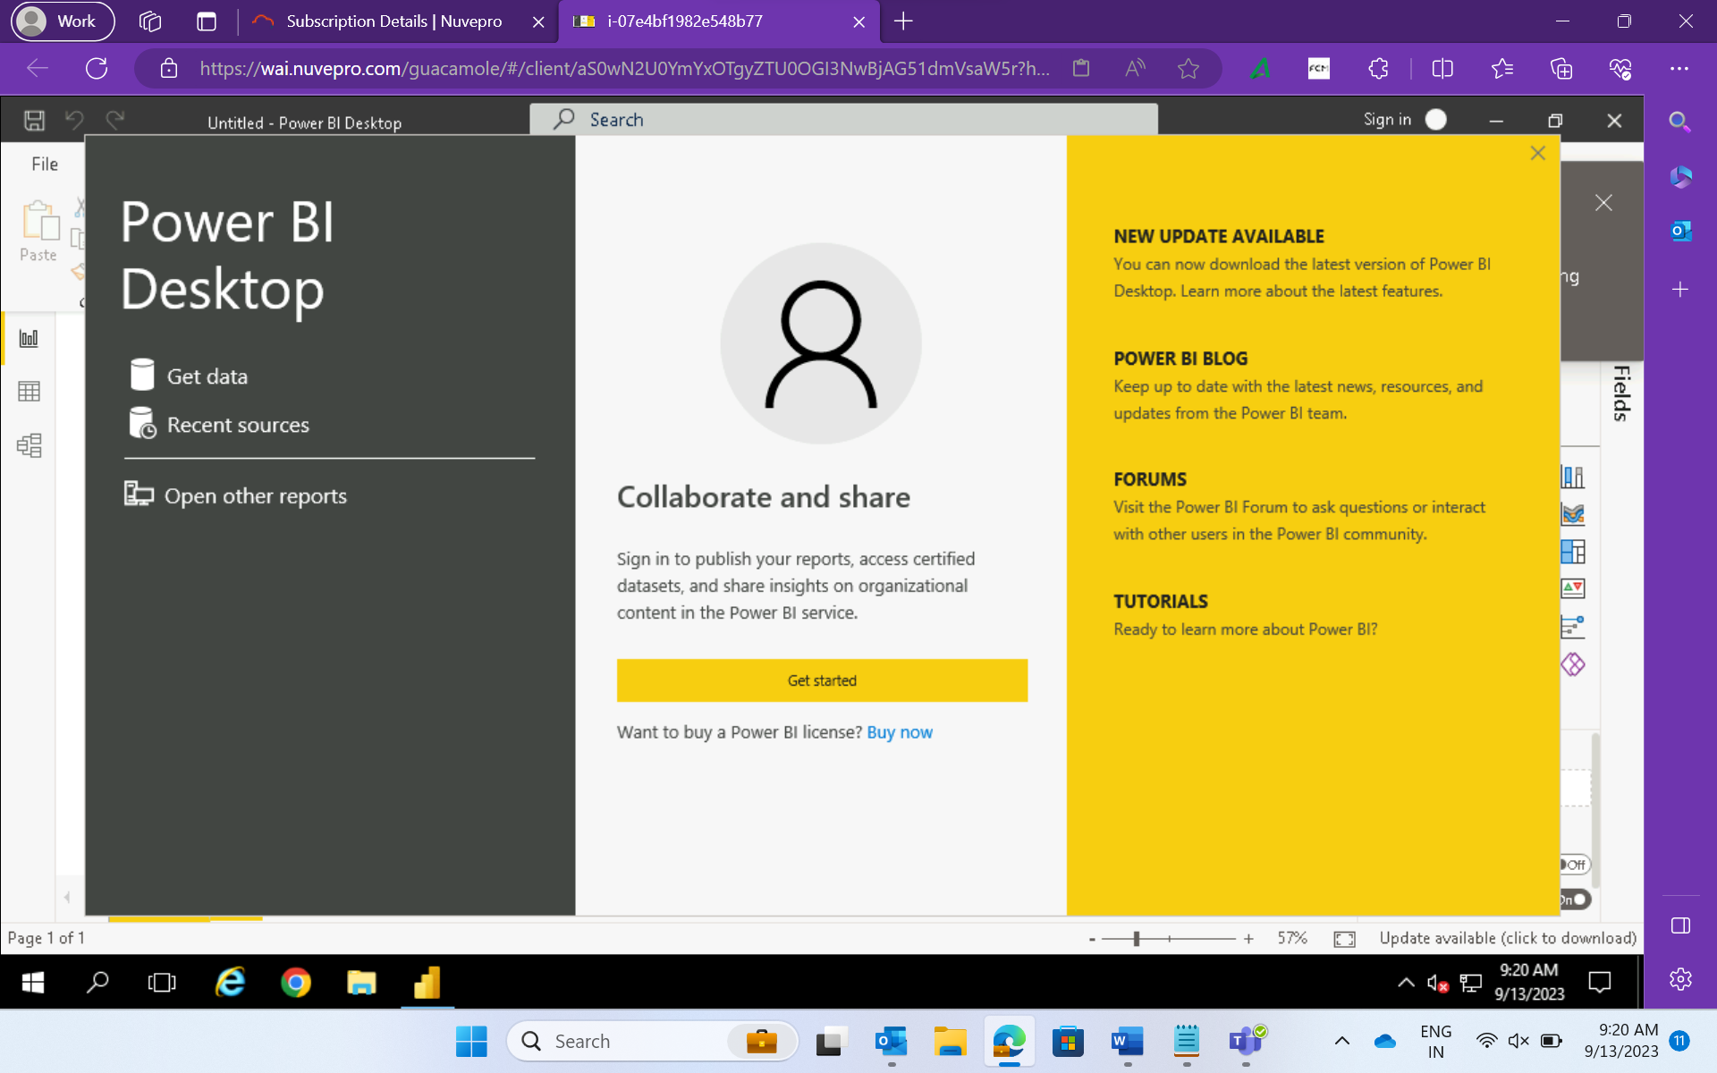

* Power Query
* Power Map
* Power View
* Power Pivot
* **Available data sources in Power BI:**
* SQL Database
* OData Feed
* Blank Query
* Azure Cloud platform
* Online Services
* Blank Query
* Other data sources such as Hadoop, Exchange, or Active Directory
* Power Query: Data transformation and data preparation tool within Microsoft Excel and Power BI.
* Streamlines the process of importing data from a variety of file types including excel tables, csv files, database tables, web pages and so on and allows you to transform your data into proper shape and condition for better analysis.
* Power Query uses M language to transform data.
* DAX: Data Analysis Expression
* Eliminating Duplicates

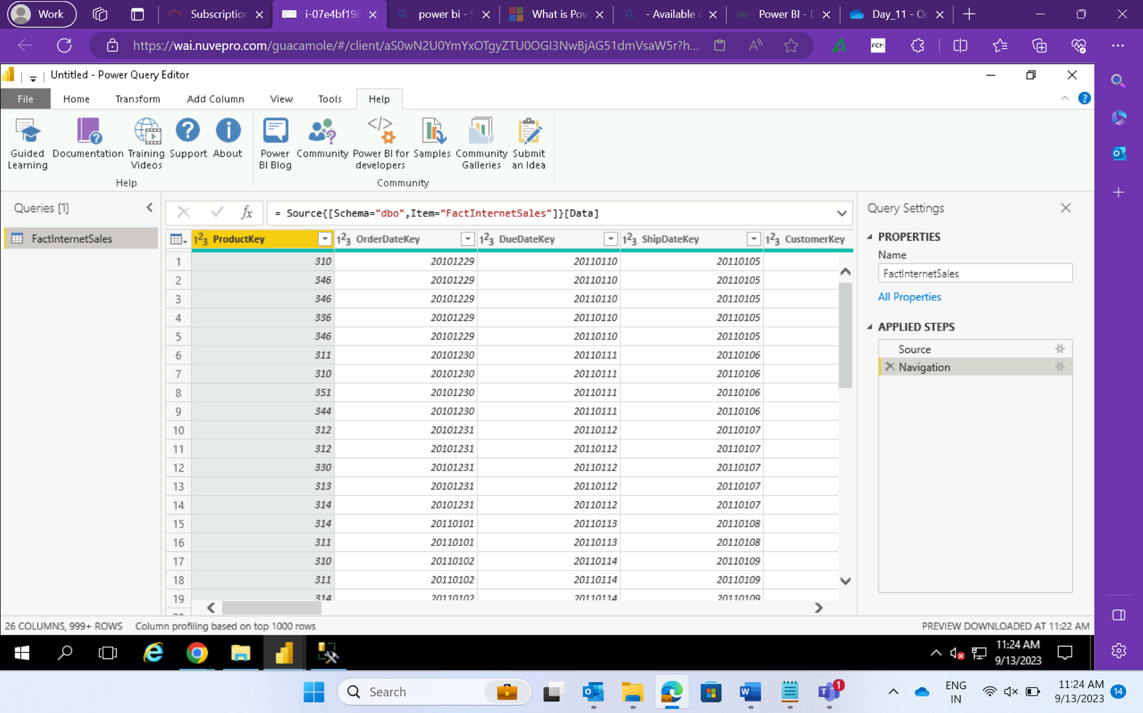

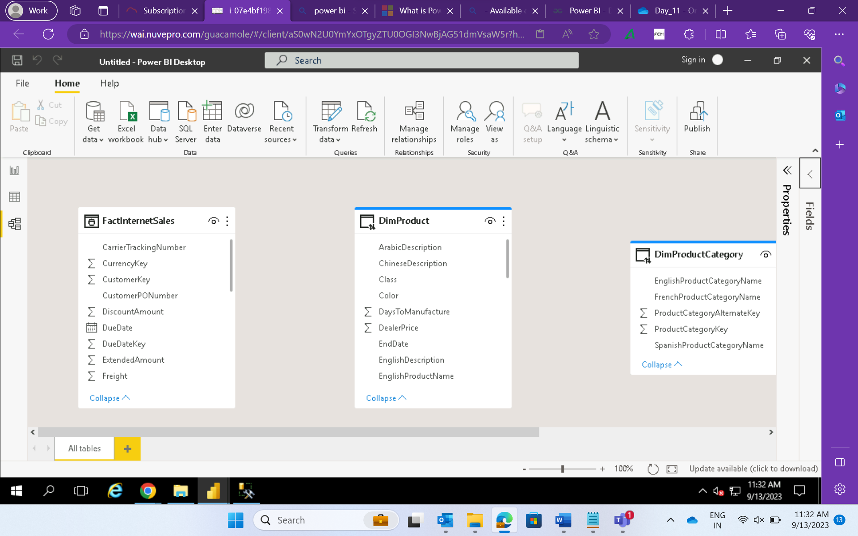

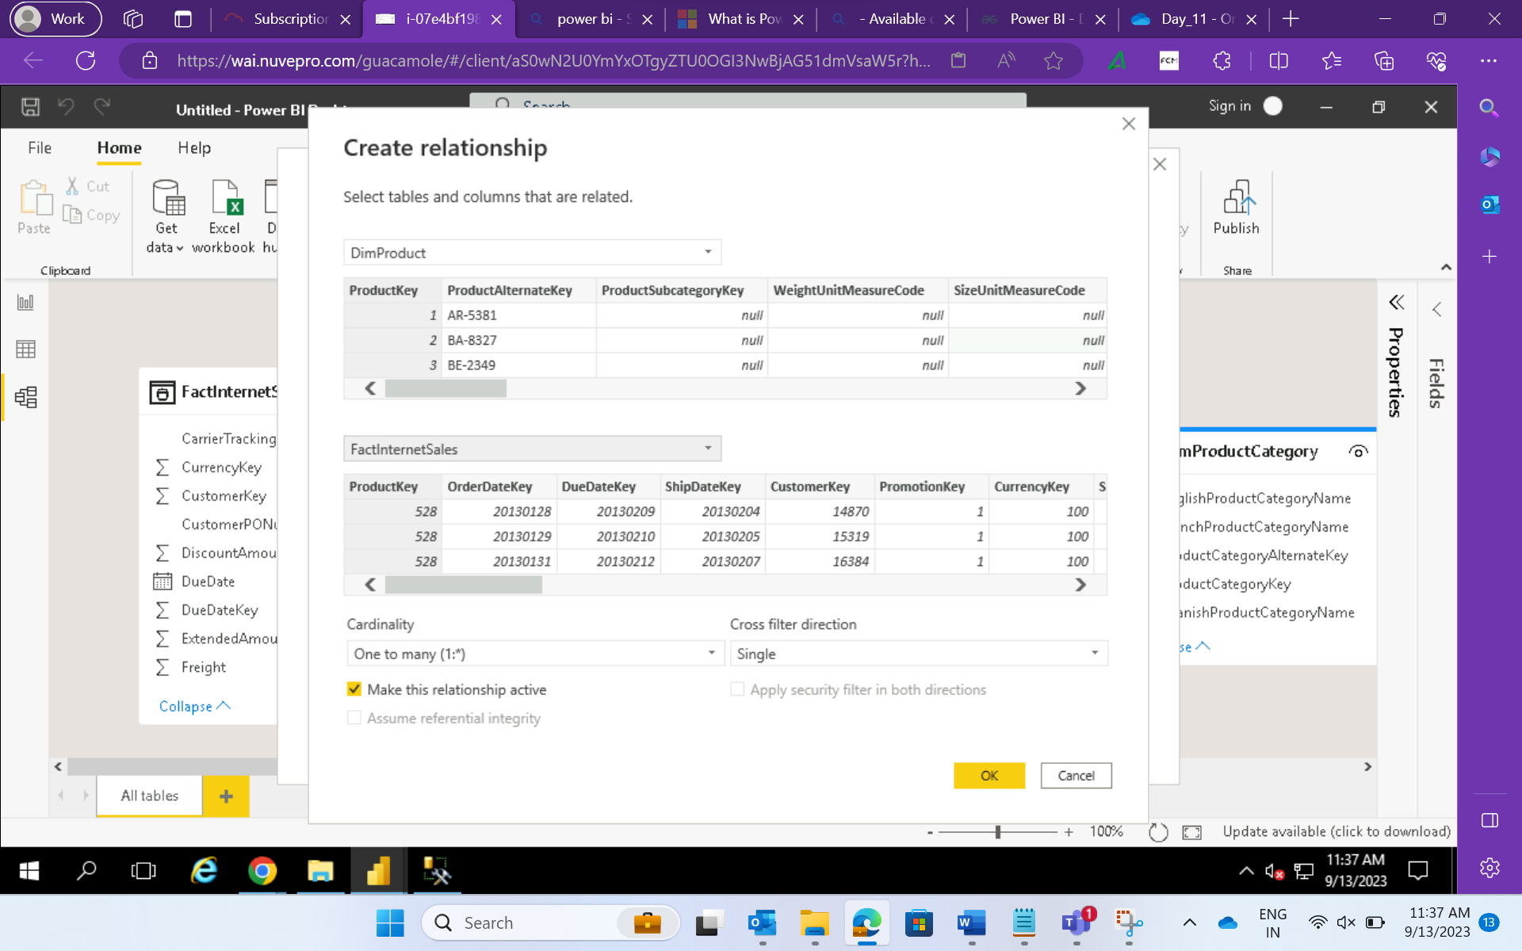

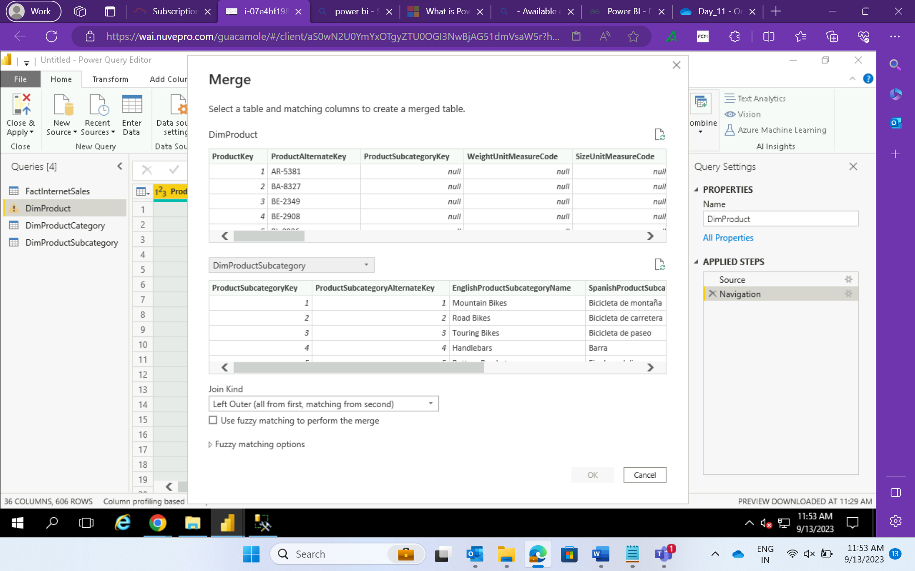

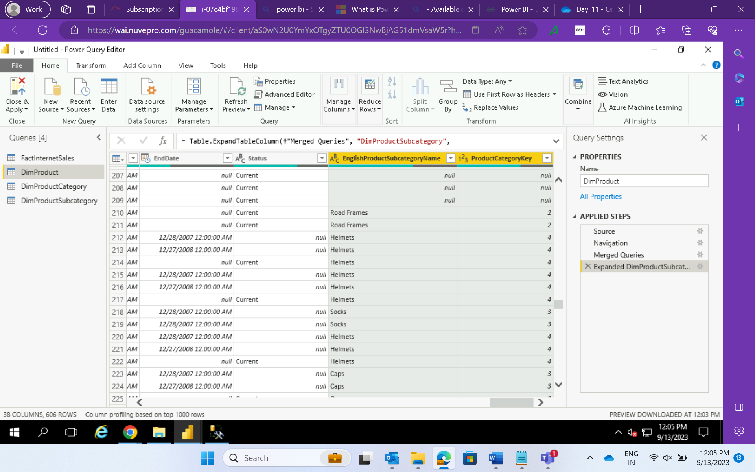

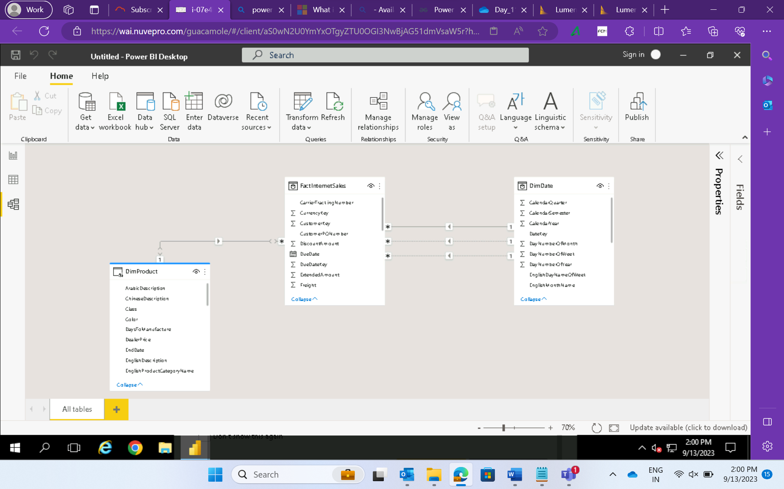

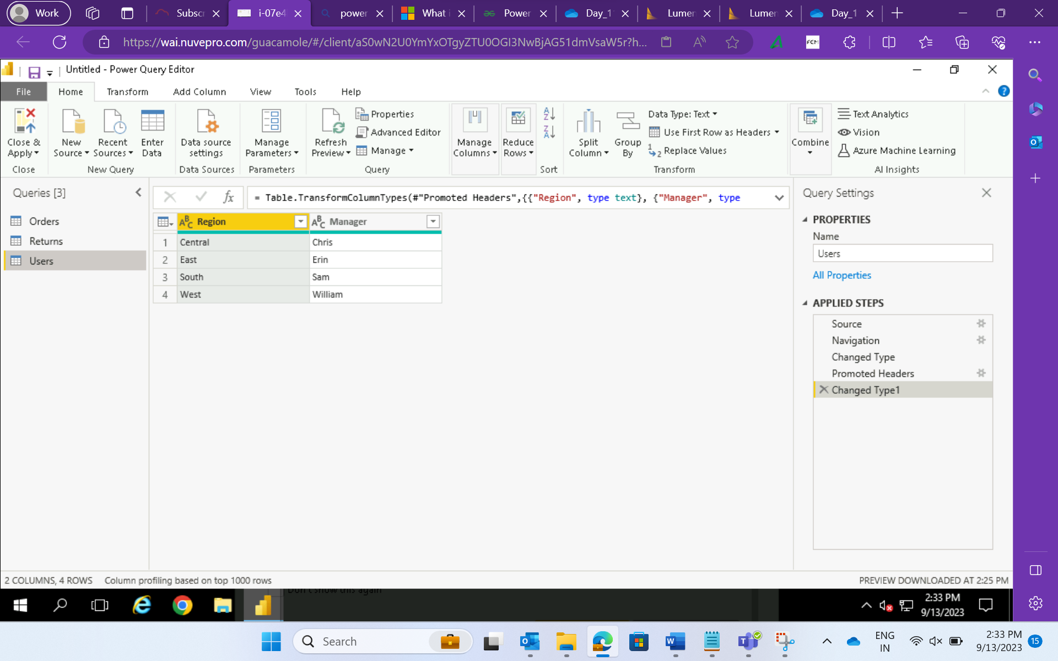

Calculated columns and majors

